SIMATS ENGINEERING

COMMON ASSESSMENT

COURSE NAME: OBJECT ORIENTED ANALYSIS AND DESIGN COURSE CODE: CSA1109
COURSE OUTCOME COVERED
CO1: Analyse the fundamentals of Object-Oriented Systems Development, including object basics, Object-Oriented Systems Development Life Cycle, Object-Oriented Methodologies, Model-Driven Development (MDD), and Agile practices.
CO2: Apply UML techniques including Use Case, Class, Interaction, State Transition, Activity, Package, Component, and Deployment Diagrams to model a software system.
CO3: Analyse objects, classes, attributes, methods, and relationships through Use Case Modelling, Object Analysis, Classification, and identification of object
relationships.
Assignment Weightage: 100%

QUESTIONS: 1 TotalMarks:100
Annexure A

Assignment

Code of Conduct:

I Akash A (Name / Reg No) certify that this submission is my original work and that I have adhered to the guidelines specified for this assessment.
I understand that any violation of academic integrity rules will result in disciplinary action.

Signature of the student: A Akash

Annexure A
Assignment

- Object-Oriented Analysis and UML-Based Design of an Autonomous Drone-Based Disaster Response and Rescue System (ADDRRS)

- Problem Analysis and Requirement Summary Problem Statement:
The Autonomous Drone-Based Disaster Response and Rescue System (ADDRRS) is designed to assist emergency teams during disasters such as
floods, earthquakes, fires, and landslides. The system uses autonomous drones equipped with cameras and sensors to collect real-time information about
affected areas, locate victims, monitor environmental conditions, and transmit data to a central command system.

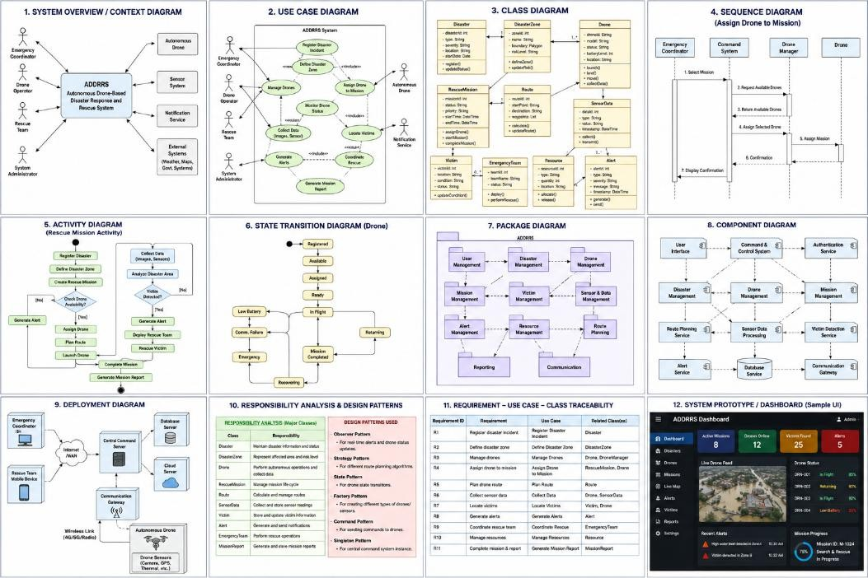

Functional Requirements:
  - Register and manage disaster incidents.
  - Define and manage disaster zones.
  - Register and monitor drones.
  - Assign drones to rescue missions.
  - Plan and update drone routes.
  - Collect images, videos, GPS locations, and sensor readings.
  - Locate and record victims.
  - Monitor drone status in real time.
  - Generate emergency alerts.
  - Coordinate emergency teams and resources.
  - Handle drone failures and communication loss.

Non-Functional Requirements:
  - Real-time communication.
  - High reliability and availability.
  - Secure access for authorized personnel.
  - Scalability for multiple disasters and drones.
  - Fast response time.
  - Maintainability and flexibility.
  - Fault tolerance and failure handling.

Actor Identification

Actor Responsibility
Emergency Coordinator Registers incidents and manages rescue operations Drone Operator Monitors and controls drones when required Rescue Team Performs physical rescue operations
System Administrator Manages users, drones, and system configuration Autonomous Drone Collects data and performs assigned missions
Central Command System Processes and manages disaster information Victim Person identified as requiring rescue
Sensor System Provides environmental readings Notification Service Sends emergency alerts and notifications

Use Case Descriptions Major use cases:
- Register Disaster Incident
- Define Disaster Zone
- Register Drone
- Assign Drone to Mission
- Plan Drone Route
- Launch Drone
- Monitor Drone

- Collect Sensor Data
- Capture Images/Videos
- Detect/Locate Victim
- Generate Alert
- Coordinate Rescue Team
- Manage Resources
- Handle Drone Failure
- Complete Rescue Mission
- Generate Mission Report

Example Use Case
Use Case: Assign Drone to Rescue Mission
Primary Actor: Emergency Coordinator
Precondition: Disaster incident and drone are registered.

Main Flow:
- Coordinator selects a rescue mission.
- System displays available drones.
- Coordinator selects a suitable drone.

Use Case Diagram
The Use Case Diagram should contain the ADDRRS system boundary.

Major use cases inside the boundary:
  - Manage Disaster
  - Manage Disaster Zone
  - Manage Drones
  - Assign Mission
  - Plan Route

  - Launch Drone
  - Monitor Drone
  - Collect Data
  - Locate Victim
  - Generate Alerts
  - Coordinate Rescue
  - Manage Resources
  - Handle Failure
  - Generate Reports
External actors should be placed outside the system boundary.

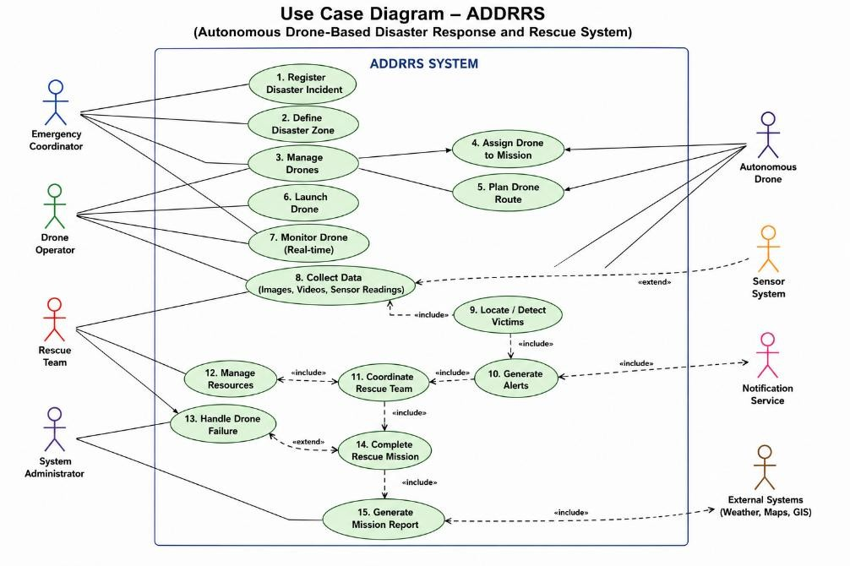

Object and Class Identification Major Objects
  - Disaster
  - DisasterZone
  - Drone

  - DroneOperator
  - RescueMission
  - Victim
  - EmergencyTeam
  - SensorData
  - Alert
  - Resource
  - Route
  - MissionReport
  - EmergencyCoordinator

Major Classes
Class Important Attributes Important Methods

Drone droneId, status, location,
batteryLevel
Disaster disasterId, type, severity,
location
DisasterZone zoneId, boundary,
riskLevel
launch(), land(), move(), collectData()

register(), updateStatus()

defineZone(), updateRisk()

RescueMission missionId, status, priority assignDrone(), startMission(),
completeMission()

Victim victimId, location, condition
EmergencyTeam teamId, teamName,
status
SensorData dataId, type, value,
timestamp
updateCondition(), requestRescue()

deploy(), performRescue() collect(), transmit()

Class Important Attributes Important Methods

Alert alertId, type, severity, message
Route routeId, startPoint, destination
generate(), send()

calculate(), updateRoute()

Resource resourceId, type, quantity allocate(), release()

MissionReport reportId, summary,
timestamp
generate(), store()

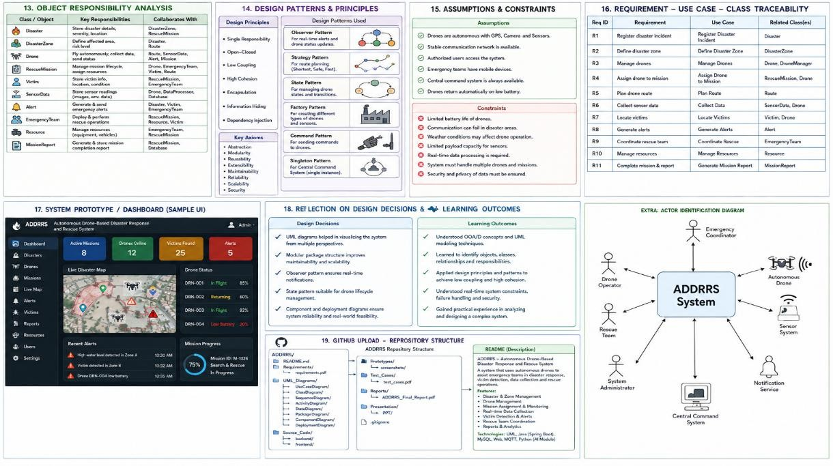

Class Diagram
The Class Diagram should show relationships such as:
  - Disaster → DisasterZone
  - Disaster → RescueMission
  - RescueMission → Drone

  - RescueMission → EmergencyTeam
  - Drone → SensorData
  - Drone → Route
  - Drone → Alert
  - RescueMission → Victim
  - EmergencyTeam → Resource
  - RescueMission → MissionReport

Important relationships:
  - Association
  - Aggregation
  - Composition
  - Generalization
  - Dependency Example:
Disaster
|
| 1..*
|
DisasterZone

RescueMission
| Drone
| EmergencyTeam
| Victim
| Route
| MissionReport

Drone
| SensorData
| Alert

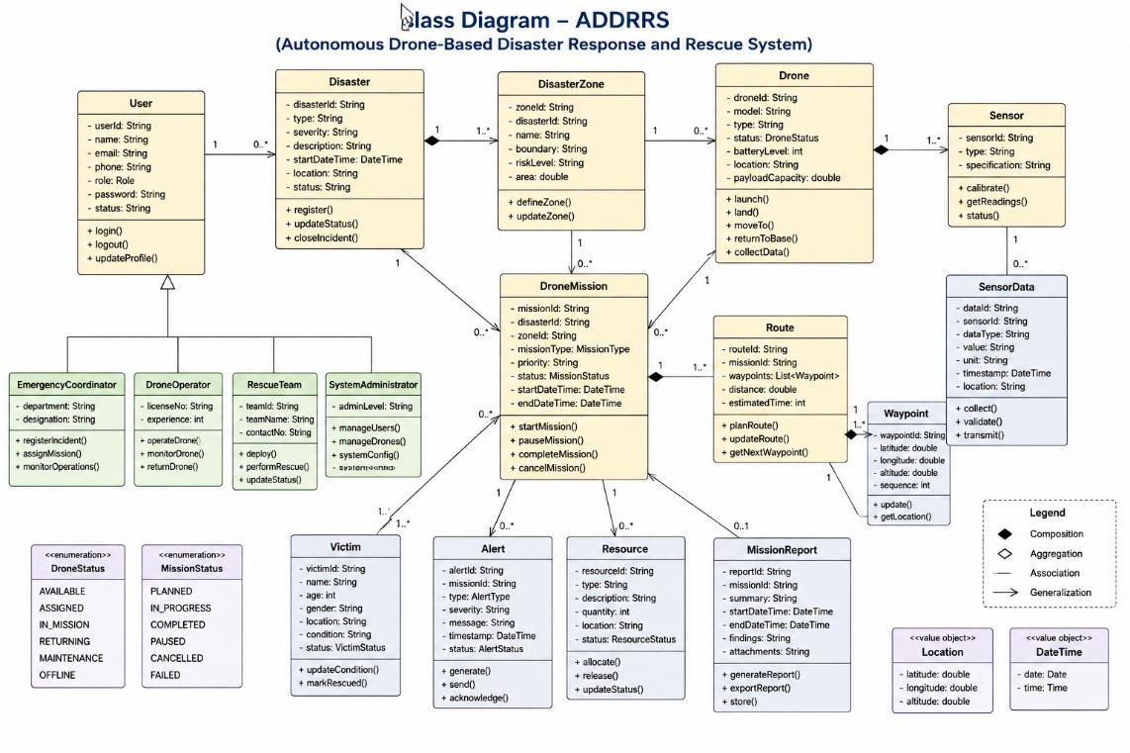

Sequence / Interaction Diagrams
You can create 2–3 sequence diagrams.

Sequence Diagram 1: Assign Drone to Rescue Mission
Emergency Coordinator
|
| Select Mission v
Command System
|
| Request Available Drones

v
Drone Manager
|
| Return Available Drone v
Command System
|
| Assign Drone v
Drone
|
| Assignment Confirmation v
Command System
|
| Display Confirmation v
Emergency Coordinator

Sequence Diagram 2: Autonomous Victim Detection
Drone
|
| Capture Image v
Camera/Sensor
|
| Image Data

v
Command System
|
| Analyze Data v
Victim Detection Module
|
| Victim Detected v
Alert Manager
|
| Emergency Alert v
Rescue Team
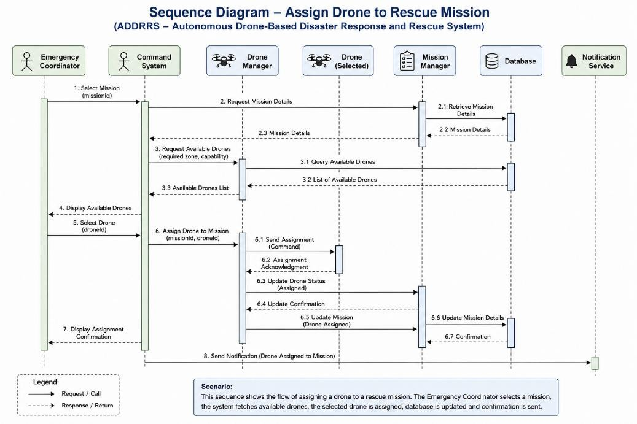

Activity Diagram Rescue Mission Activity Start
↓
Register Disaster
↓
Define Disaster Zone
↓
Create Rescue Mission
↓
Check Drone Availability
↓
Assign Drone
↓
Plan Route
↓
Launch Drone
↓
Collect Data
↓
Analyze Disaster Area
↓
Victim Detected?
┌──────────────┐ No Yes
↓ ↓

Continue Generate Alert Monitoring ↓
↓ Deploy Rescue Team Mission ↓
Complete Rescue Victim
\ /
↓ ↓
Generate Report
↓ End

State Transition Diagram
The Drone is a suitable object for the State Transition Diagram. [Registered]
↓
[Available]
↓ [Assigned]
↓ [Ready]
↓
[In Flight]
↙ ↘
[Communication] [Mission Complete] [Failure] ↓
↓ [Returning]

[Emergency] ↓
↓ [Available] [Recovery]
Possible drone states:
- Registered
- Available
- Assigned
- Ready
- In Flight
- Returning
- Mission Completed
- Low Battery
- Communication Failure
- Emergency
- Maintenance

- Package Diagram Suggested packages: ADDRRS
│
├── User Management
├── Disaster Management
├── Drone Management
├── Mission Management
├── Victim Management
├── Sensor & Data Management

├── Alert Management
├── Resource Management
├── Route Planning
├── Reporting
└── Communication
This improves modularity and maintainability.

Component Diagram
Major components:
  - User Interface
  - Command Control System
  - Authentication Service
  - Disaster Management
  - Drone Management
  - Mission Management
  - Route Planning Service
  - Sensor Data Processing
  - Victim Detection
  - Alert Service
  - Database
  - Communication Gateway
  - Drone Controller Example:
[User Interface]
| v

[Command Control System]
|
┌─────┼──────────┐
↓ ↓ ↓
[Drone] [Mission] [Disaster] [Mgmt] [Mgmt] [Mgmt]
|
↓
[Sensor Data Processing]
|
↓
[Victim Detection]
|
↓
[Alert Service]
|
↓
[Database]

Deployment Diagram
The Deployment Diagram can contain:

Devices/Nodes
  - Emergency Coordinator Computer
  - Rescue Team Mobile Device
  - Central Command Server
  - Database Server

  - Communication Gateway
  - Autonomous Drone
  - Drone Sensors
  - Cloud Server Example:
[Emergency Coordinator PC]
|
| Internet
↓
[Central Command Server]
|
┌────┴────┐
↓ ↓
[Database] [Cloud Server]
|
↓
[Communication Gateway]
|
| Wireless Network
↓
[Autonomous Drone]
|
┌───┼────┐
↓ ↓ ↓
Camera GPS Sensors

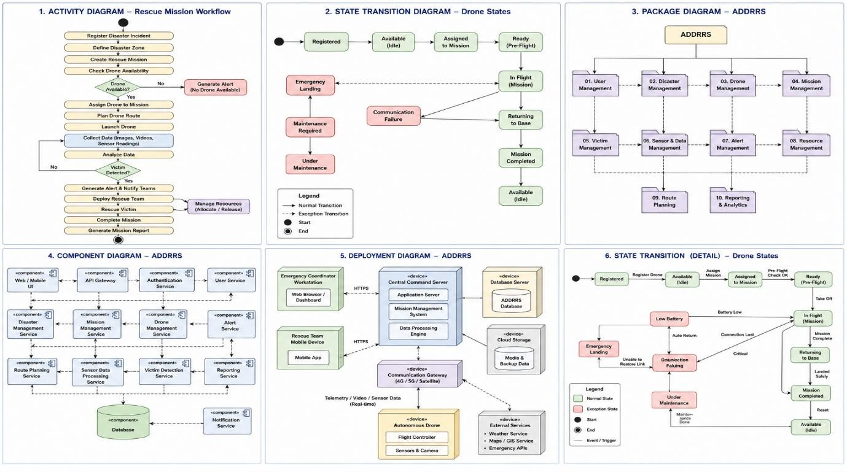

Object Responsibility Analysis
Object/Class Responsibility
Drone Execute autonomous flight and collect information
RescueMission Manage mission lifecycle
Disaster Store disaster information
DisasterZone Represent affected geographical area Route Calculate and manage drone routes Victim Maintain victim information
SensorData Store environmental readings
Alert Manage emergency notifications
EmergencyTeam Perform rescue activities
Resource Manage rescue resources

Object/Class Responsibility MissionReport Generate mission completion information DroneManager Manage drone availability and assignments

Responsibility Assignment
The design follows high cohesion by giving each class a focused responsibility and low coupling by minimizing unnecessary dependencies between classes.

Design Axioms, Principles and Design Patterns Design Principles
- High Cohesion
Each class performs closely related operations.

Low Coupling
Classes depend on interfaces rather than unnecessary concrete implementations.

Single Responsibility Principle
Each class has one major responsibility.

Open/Closed Principle
New drone or sensor types can be added without major changes to existing code.

Encapsulation
Internal data such as drone status and battery level is protected through appropriate methods.

Suitable Design Patterns
Pattern Application

Observer Pattern
Real-time drone status and alert notifications

Strategy Pattern Different route-planning algorithms

Pattern Application
Factory Pattern Creating different drone/sensor objects
State Pattern Managing drone states

Command Pattern
Singleton Pattern
Sending commands to autonomous drones

Central command/control manager, if a single shared instance is required

Assumptions and Constraints Assumptions
  - Only authorized personnel can access the system.
  - Drones have GPS capability.
  - Drones have cameras and environmental sensors.
  - A communication network is available in most operational areas.
  - Emergency teams have suitable communication devices.
  - The central system maintains a database.
  - Drones can operate autonomously after mission assignment.

Constraints
  - Limited drone battery capacity.
  - Possible communication failures.
  - Poor weather conditions may affect drone operation.
  - GPS signals may become unavailable.
  - Network bandwidth may be limited.
  - System must handle multiple drones simultaneously.
  - Security must prevent unauthorized access.
  - Real-time data processing is required.

Requirement-to-Use Case/Class Traceability

Requirement | Use Case | Related Classes
Register disaster | Register Disaster | Disaster

Define affected area Define Disaster
Zone
DisasterZone

Manage drones Manage Drone Drone, DroneManager Assign drone Assign Drone Drone, RescueMission
Plan route Plan Route Route
Collect sensor data Collect Data Drone, SensorData Locate victims Locate Victim Victim, Drone

Generate emergency notification
Generate Alert Alert

Coordinate rescue Coordinate Rescue EmergencyTeam,
RescueMission
Manage resources Manage Resources Resource
Complete mission Complete Mission RescueMission,
MissionReport

Implementation / Prototype and Result:
A simple prototype can demonstrate:
  - Login page
  - Disaster registration
  - Drone registration
  - Drone status dashboard
  - Mission assignment
  - Disaster-zone display
  - Victim information
  - Sensor-data monitoring
  - Emergency alerts
  - Mission report generation

Expected Result
The prototype should demonstrate that emergency personnel can register disasters, assign drones, monitor autonomous operations, receive collected information, identify victims, generate alerts, coordinate rescue teams, and complete rescue missions.

Reflection on Design Decisions and Learning Outcomes
The development of ADDRRS demonstrates the application of Object-Oriented Analysis and Design principles to a real-world emergency-response problem. UML diagrams helped identify system actors, objects, classes, relationships, workflows, interactions, states, components, and deployment nodes.

The project provided practical understanding of:
  - Object identification and classification.
  - Use Case Modelling.

  - UML diagram development.
  - Class and relationship identification.
  - Responsibility assignment.
  - Object-oriented design principles.
  - Design patterns.

- GitHub Upload
https://github.com/akkurthiakash/CSA1109

